BC2402: Designing and Developing Databases

Week 9 Class Exercises – Basic Create Operations

Case: A simple clinic
Consider the following sample document (database = simpleClinic, collection = patients):
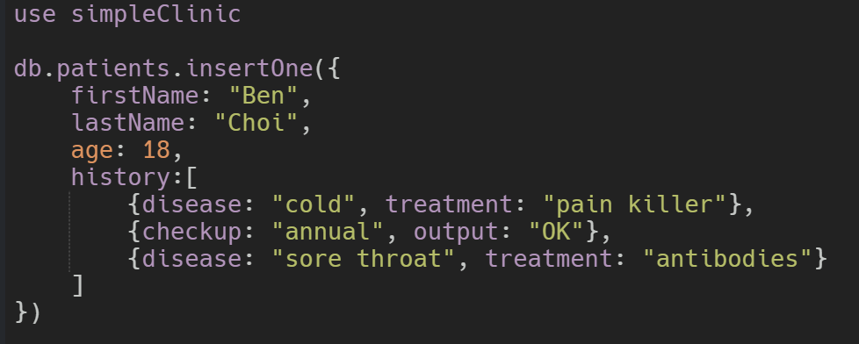
Required:
- Create the above database and collection.
- Insert the above document into the collection.
- Insert 3 additional patient records (documents) with at least 1 history entry per patient.
- Test out your database with find().
- Find all patients who are older than 30 years old (or a value of your choice).
- Delete all patients who got a flu as a disease.

Case: Amazon Prime
Amazon Prime is a paid subscription program from Amazon that gives users access to additional services otherwise unavailable or available at a premium to regular Amazon customers. Services include same, one or two-day delivery and streaming music and video. In January 2020, Amazon reported that Prime had more than 150 million subscribers worldwide.
During May 2020, Amazon.com had over 2.5 billion combined desktop and mobile visits, up from 2.01 billion visits in February 2020. The platform is by far the most visited e-commerce property in the United States.

Some fun facts about Amazon
- 9 out of 10 consumers price check a product on Amazon.
- Amazon sells more than 12 million products.
- 95 million people have Amazon Prime memberships in the US.
- $1.4K is the average spent by Amazon Prime members each year.
- Amazon shipped over 5 billion items worldwide in 2017.

ERD
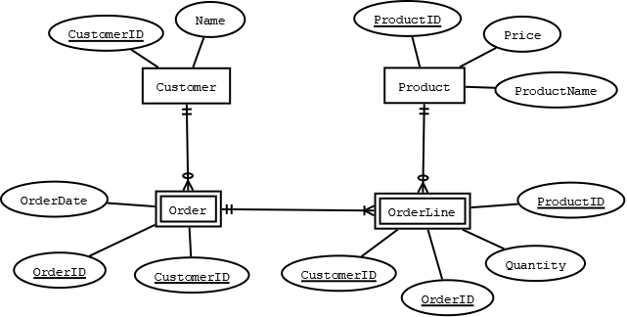

Sample Records
Customer
CustomerID | Name
1000 | Ben Choi
1001 | Jayden Choi
1002 | Cammy Soh
1004 | Mason Greenwood
1005 | Dean Henderson

Product
ProductID | ProductName | Price
50001 | Scott Pick A Size Multi Purpose Towels | 4.25
50002 | Japanese Super Crispy Chicken | 11.80
50003 | Vegan Beyond Burger Plant Based Patties Beef | 14.90
50004 | Korean Honey Sweet Potato | 9.90
50005 | Premium Atlantic Salmon 1Kg | 22.00

Order
OrderID | CustomerID | OrderDate
1880001 | 1000 | 2020/01/21
1880002 | 1000 | 2020/01/22
1880003 | 1000 | 2020/01/23
1880004 | 1001 | 2020/01/22
1880005 | 1001 | 2020/01/23
1880006 | 1004 | 2020/01/24
1880007 | 1005 | 2020/01/25

OrderLine
CustomerID | OrderID | ProductID | Quantity
1000 | 1880001 | 50001 | 2
1000 | 1880001 | 50003 | 1
1000 | 1880002 | 50002 | 2
1000 | 1880003 | 50004 | 4
1000 | 1880003 | 50005 | 2
1001 | 1880004 | 50003 | 1
1001 | 1880004 | 50004 | 1
1001 | 1880005 | 50002 | 2
1004 | 1880006 | 50004 | 1
1004 | 1880006 | 50005 | 1
1005 | 1880007 | 50002 | 2
1005 | 1880007 | 50003 | 1
1005 | 1880007 | 50001 | 2

Required:
- Create a MongoDB to capture the above records (database name = amazonPrime). You can use a maximum of 3 collections.
- Insert the records in the above tables into documents in each collection. You must observe the relationships depicted in the ERD, either by reference or embedded documents.
- Give a brief justification on your data model in a word document.

